**Creating General Query Action**

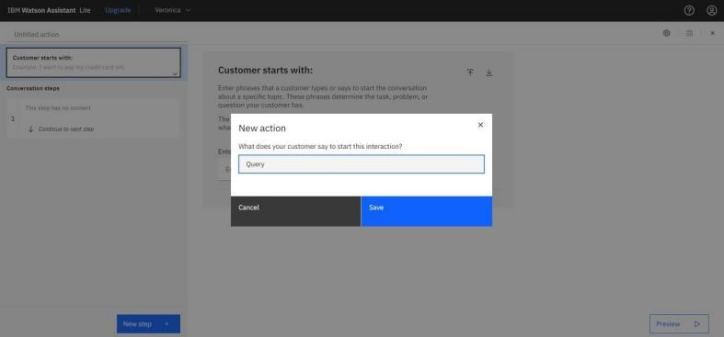

Adding steps in Query action to handle queries regarding Bank working hours, Currency conversion policy,Storage locker facility, CIBIL score, list of all branches, nearest available branch, etc.,

